Measuring a security door
Important: always measure the door from outside looking in, e.g.: standing outside the house

Method
1. Measuring from an existing screen door: If you have an existing door, and you are happy with the fit then we suggest that you measure this door and use these measurements for your new door.
Door Height: Measure from top to bottom of the screen door on both the left and right hand sides; send us the shortest of the two measurements.
Door Widths: Measure the top, middle and bottom widths of the screen door; send us all three measurements.
Lock Height: You can use the existing lock hole cut out if desired; first make sure that the new handle will not interfere with the existing solid door handle, do this by referring to the Lock Above & Lock Below instructions at the bottom of the page. Then measure from the bottom of the existing screen door up to the centre of the existing striker, this will be the centre of the new striker and screen door handle.

2. Measuring for a new screen door:
Door Height: Measure from top (1.1) to bottom (1.2) on both sides of your door frame, deduct 8 mm from the shortest side and record this measurement. Keeping the sides the same length will allow us to build your door square.
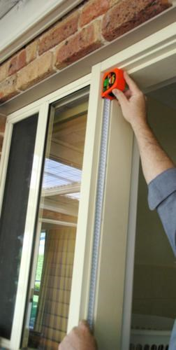 | 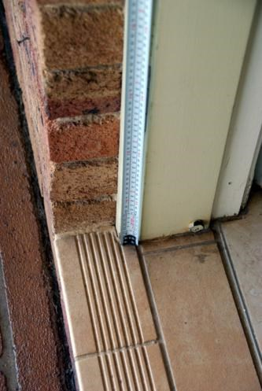
1.1 1.2
Note: A bug seal is recommended to minimise gap at the bottom after the door is installed. This can be selected from the list of Add Ons available when calculating the price of your door.
Door Width: Measure the top, middle and bottom of your door frame (1.3), deduct 8 mm for a single lock and 9 mm for a triple lock from each, record these measurements. Any variation in the middle measurement will be made to the lock side of the door, the hinge side will be made straight to avoid hinge bind.
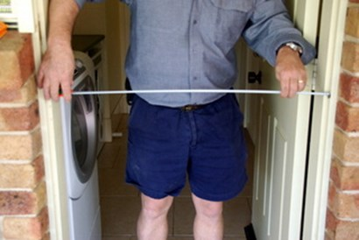
1.3
Hinge Bind: If your middle width is longer or shorter, creating a bow in or out at the middle, this must be corrected. For a bow in the centre the hinge can be packed out (0.5 mm Hinge Packers are available on the Extras page). For a bow out, the hinge will have to be let in, this must be done by altering the timber door frame, however you can request to have the middle hinge raised, lowered or supplied with the door and not affixed.
Lock: Stand outside, close the main solid door. Establish whether you want the new lock on the left or right hand side, then if you want the new lock above the existing door handle or below.
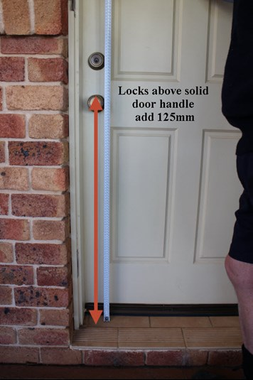 | 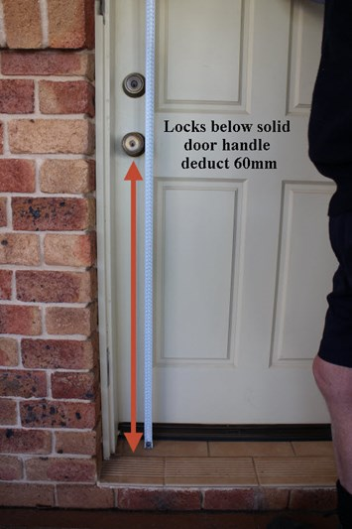
1.4 1.5
Lock Above: Measure from the bottom sill to the top of the existing solid door handle and add 125 mm (1.4). This will be the new door handle and tongue height.
Lock Below: Measure from the bottom sill to the bottom of the existing solid door handle and deduct 60 mm (1.5). This will be the new door handle and tongue height.
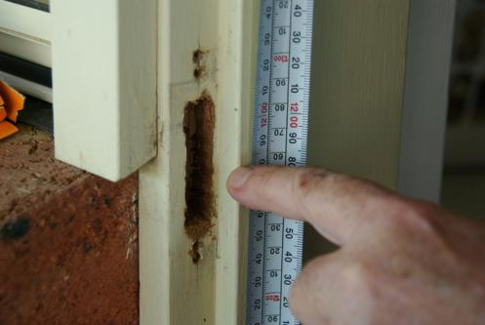
1.6
If you have an existing lock hole (1.6) from a previous door and you are confident that this has clearance from the existing lock, based on the Lock Above & Lock Below guidelines, then measure from bottom sill to the centre of the lock hole and deduct 4 mm. This will be the handle height. The centre of the lock tongue is the centre of the handle.

