11 Jacobsen Crescent
Holden Hill SA 5088
PH: 08 8369 2266
FAX: 08 8266 9899
Web: www.classicrollershutters.com.au

SETTING THE LIMITS ON AN ELECTRIC MOTOR
At the motor end of the Roller Shutter you will see a Yellow and a White button. These are to set the stop position of the Roller Shutter at the fully open and fully closed position.
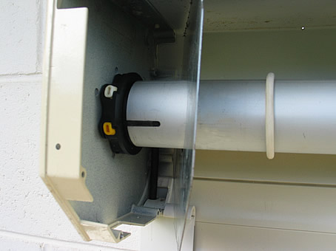  SOMFY electric motor on  left side of roller shutter | 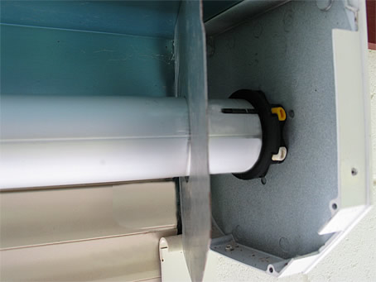  SOMFY electric motor on  right side of roller shutter.
White button is to set the down limit, the yellow button is to set the upper limit. | Yellow button is to set the down limit, the white button is to set the upper limit.
With both buttons depressed, you can now commence to set your 'up' and 'down' limits. It would be advisable to begin the limit setting with the curtain in the middle position and practice setting the limits until you are confident and comfortable with this procedure.

Setting the lower limit position:
Power the motor down and stop the curtain at the Down limit position. Press the corresponding limit button on the HiPro motor until the button springs up.
The lower limit positions has been set. 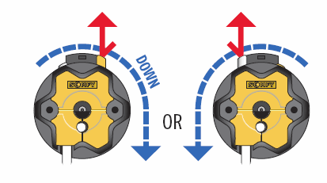
Setting the up limit position:
Power the motor up and stop the curtain at the Up limit position. Press the corresponding limit button on the HiPro motor until the button springs up.
The upper limit positions has been set. 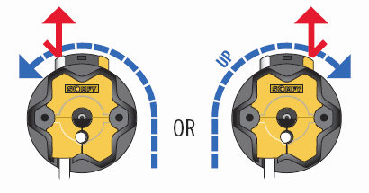
Please note:If the shutter height limit is not set correctly, the bottom bar of the curtain has a bottom bar V stopper each side, which stops the curtain from going completely into the head box, but this causes the motor to jam and stop, this should be avoided and the up limit set to stop the curtain before this happens.

